

**Computer Networks**

**2nd Year, 2nd Semester**

**2018**

**Introduction Lab**

**Introduction to Cisco Packet Tracer and Setting up of a Simple LAN**



** Follow the lab sheet and if you need any clarifications get assistance from a lab instructor.

**Activity 1 – Familiarizing with Packet Tracer Interface**

1. Open Cisco Packet Tracer from your start menu programs.
2. Verify the following controls and understand the functionality of each.

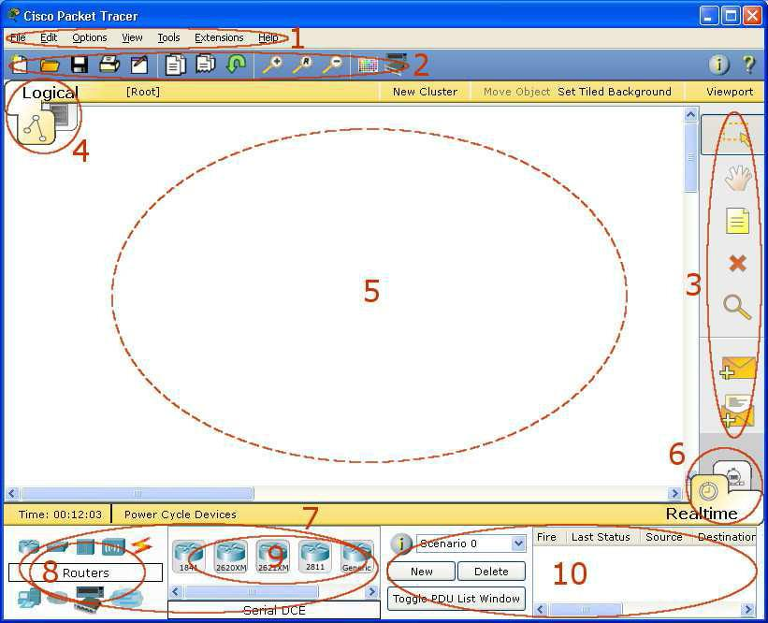

|  |  |  |  |
| --- | --- | --- | --- |
| 1 | **Menu Bar** |  | This bar provides the **File**, **Edit**, **Options**, **View**, **Tools**, |
|  |  |  | **Extensions**, and **Help** menus. You will find basic commands such |
|  |  |  | as **Open**, **Save**, **Print**, and **Preferences** in these menus. You will |
|  |  |  | also be able to access the **Activity Wizard** from the **Extensions** |
|  |  |  | menu. |
| 2 | **Main Tool Bar** | | This bar provides shortcut icons to the **File** and **Edit** menu |
|  |  |  | commands. This bar also provides buttons for **Zoom**, the drawing |
|  |  |  | **Palette**, and the **Device Template Manager**. On the right, you will |
|  |  |  | also find the **Network Information** button, which you can use to |
|  |  |  | enter a description for the current network (or any text you wish to |
|  |  |  | include). |
| 3 | **Common Tools** | | This bar provides access to these commonly used workspace tools: |
|  | **Bar** |  | **Select**, **Move Layout**, **Place Note**, **Delete**, **Inspect**, **Add Simple** |
|  |  |  | **PDU**, and **Add Complex PDU**. |
| 4 | **Logical/Physical** | | You can toggle between the Physical Workspace and the Logical |
|  | **Workspace** | **and** | Workspace with the tabs on this bar. |
|  | **Navigation Bar** | |  |
|  |  |  | In Logical Workspace, this bar also allows you to navigate through |
|  |  |  | levels of a cluster, create a **New Cluster**, **Move Object**, **Set Tiled** |
|  |  |  | **Background**, and **Viewport**. |
|  |  |  | In Physical Workspace, this bar allows you to navigate through |
|  |  |  | physical locations, create a **New City**, create a **New Building**, |
|  |  |  | create a **New Closet**, **Move Object**, apply **Grid** to the background, |
|  |  |  | **Set Background**, and go to the **Working Closet**. |
| 5 | **Workspace** |  | This area is where you will create your network, watch simulations, |
|  |  |  | and view many kinds of information and statistics. |
| 6 | **Realtime/Simulation** | | You can toggle between Realtime Mode and Simulation Mode with |
|  | **Bar** |  | the tabs on this bar. This bar also provides buttons to **Power Cycle** |
|  |  |  | **Devices** as well as the **Play Control** buttons and the **Event List** |
|  |  |  | toggle button in Simulation Mode. Also, it contains a clock that |
|  |  |  | displays the relative **Time** in Realtime Mode and Simulation |
|  |  |  | Mode. |
| 7 | **Network** |  | This box is where you choose devices and connections to put into |
|  | **Component Box** | | the workspace. It contains the **Device-Type Selection** Box and the |
|  |  |  | **Device-Specific Selection** Box. |
| 8 | **Device-Type** |  | This box contains the type of devices and connections available in |
|  | **Selection Box** | | Packet Tracer. The **Device-Specific Selection** Box will change |
|  |  |  | depending on which type of device you choose. |
| 9 | **Device-Specific** | | This box is where you choose specifically which devices you want |
|  | **Selection Box** | | to put in your network and which connections to make. |
| 10 | **User** | **Created** | This window manages the packets you put in the network during |
|  | **Packet** |  | simulation scenarios. |
|  | **Window** |  |  |

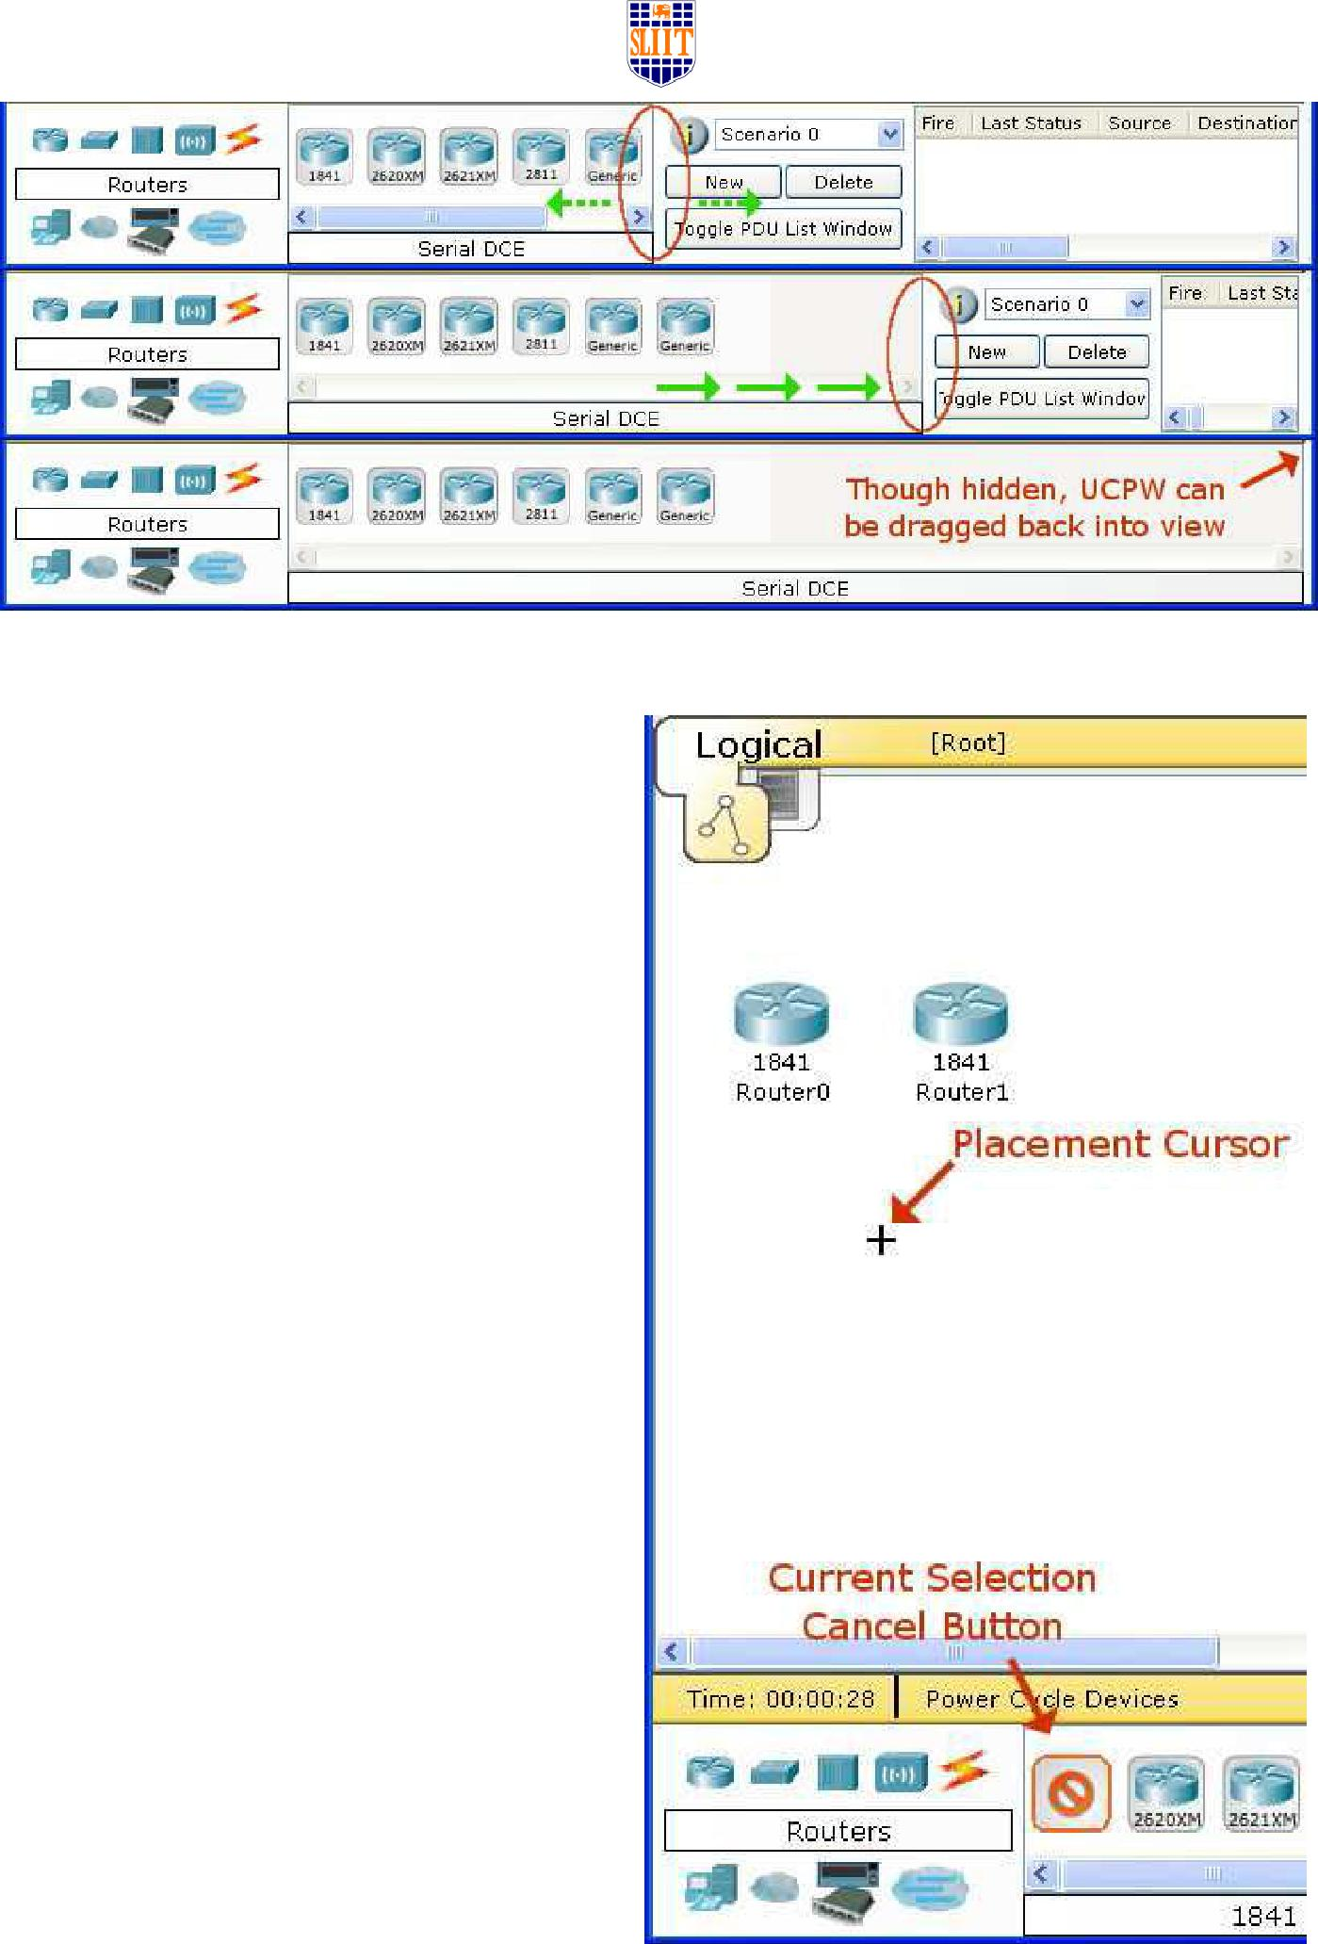

**Activity 2 - Adding devices in to the Workspace**

1. Choose a device type from the **Device-Type Selection** box.
2. Click on the desired device model from the **Device-Specific Selection** box.
3. Click on a location in the workspace to put your device in that location.
4. If you want to cancel your selection, press the **Cancel** icon for that device.
5. Alternatively, you can click and drag a device from the **Device-SpecificSelection** box onto the workspace.
6. You can also click and drag a device directly from the **Device-Type Selection** box and a default device model will be chosen for you.

**Activity 3 – Adding additional modules to devices**

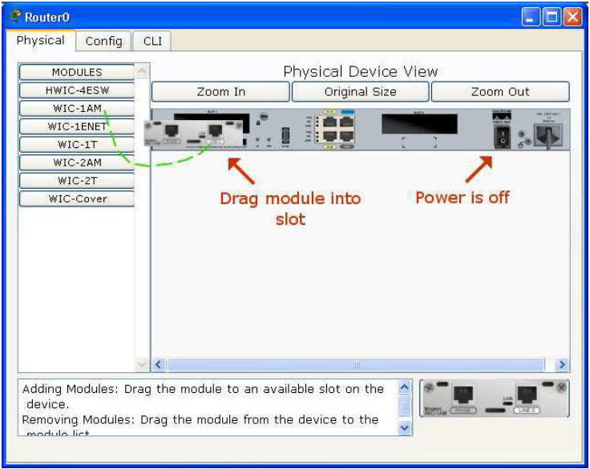

1. Click on a device to bring up its configuration window.
2. By default, you will be in the **Physical Device View** subpanel of the device.
3. You can browse (by clicking) through the list of modules and read their description in the information box at the bottom.
4. When you have found the module you want to add, simply drag it from the list into a compatible bay on the device picture.
5. You can remove a module by dragging it from the device back into the list.

**Activity 4 – Making Connections**

1. To make a connection between two devices, first click the **Connections** icon from the **Device-Type Selection** box to bring up the list of available connections.
2. Then click the appropriate cable type.
3. The mouse pointer will change into a "connection" cursor.
4. Click on the first device and choose an appropriate interface to which to connect.
5. Then click on the second device and do the same.
6. A connection cable will appear between the two devices, along with link lights showing the link status on each end (for interfaces that have link lights).

**Note:** Alternatively you can choose the **Automatically Choose Connection Type** option whichwill automatically select the cable type and ports for you.

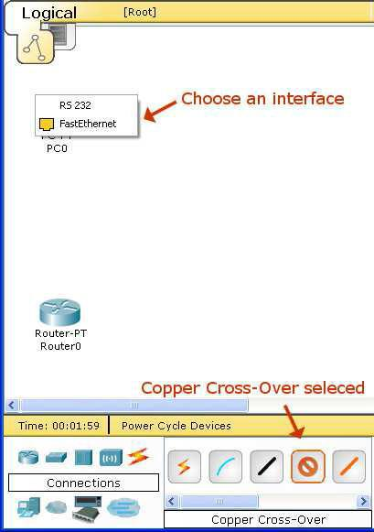

**Activity 5 – Setup a simple LAN**

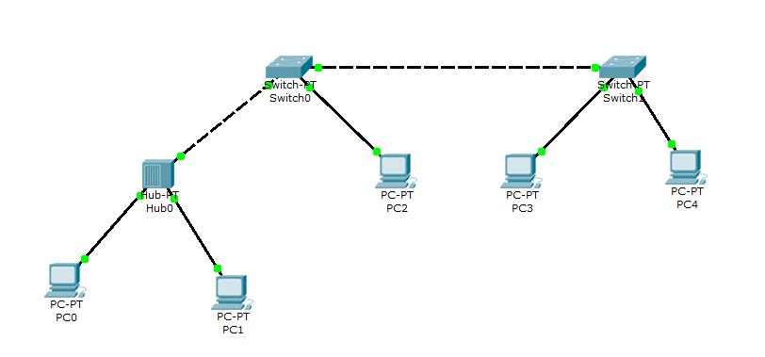

1. Prepare the simple LAN shown in above diagram in your Workspace.
2. Configure the following IP addresses in the PCs.

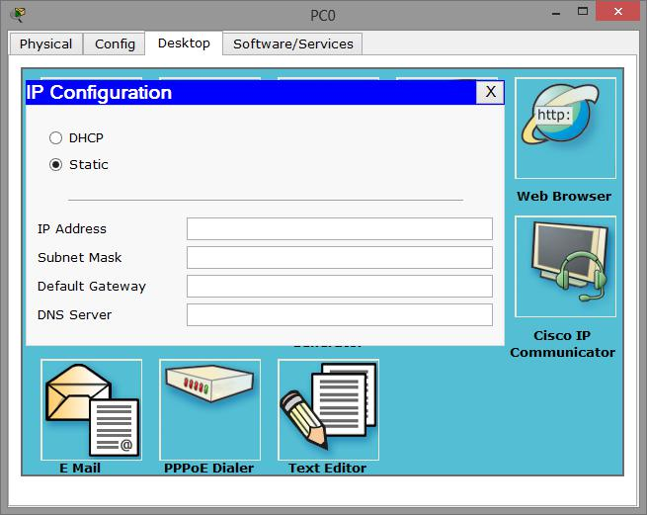

|  |  |  |
| --- | --- | --- |
| **PC** | **IP Address** | **Subnet Mask** |
| PC0 | 192.168.10.1 | 255.255.255.0 |
| PC1 | 192.168.10.2 | 255.255.255.0 |
| PC2 | 192.168.10.3 | 255.255.255.0 |
| PC3 | 192.168.10.4 | 255.255.255.0 |
| PC4 | 192.168.10.5 | 255.255.255.0 |

**Note:**

To set the IP address, click on the PC, then select the **Desktop** tab and click on the **IPConfiguration** option.



1. Use the **ping** command to verify whether you can communicate from each PC to every other PC.



**Activity 6 – Working with the Simulation mode**

1. Go to **Simulation** mode.

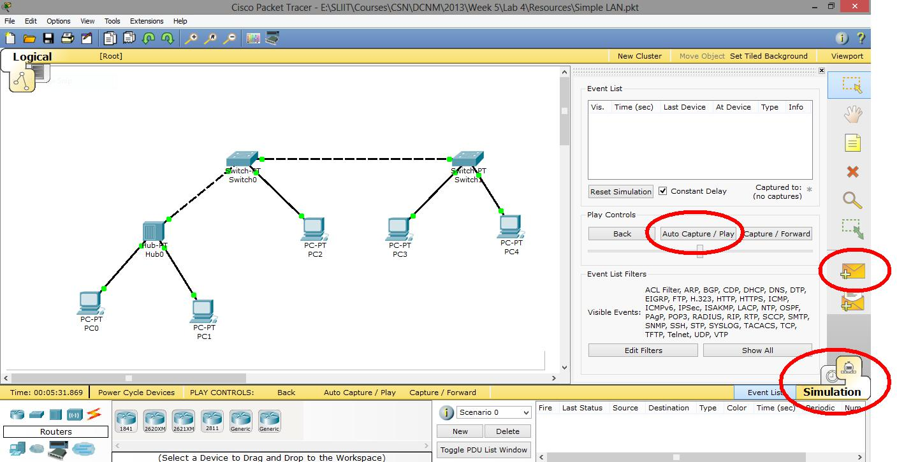

|  |  |  |
| --- | --- | --- |
| **Auto Capture / Play** | **Simple PDU** |  |
|  |  |

1. Click on **Simple PDU**, and then click on PC0 (source) and then click on PC4 (destination).
2. Now the simulation is ready. To start the simulation press **Auto Capture/Play** button. You can also navigate back and forth the simulation steps using **Back** and **Capture/Forward** buttons respectively. To reset the simulation to beginning you can use the **Reset Simulation** button.
3. Carefully observe how the packet is transferred to the destination (PC4) and how the reply comes back to source (PC0).

**Note:**

Carefully observe the functional difference between Switch and Hub. Hub sends all the packets it receives to all the PCs while Switch is transferring the packets only to the intended destination

**Activity 7 – Saving your work**

Save your Packet Tracer workspace and configurations. Packet Tracer files will be saved with

.pkt extension.

**Activity 8 - Introduction to the Routers**

**User vs. Privileged Mode**

User mode is indicated with the ‘>’ next to the router name. You can look at settings but can not make changes from user mode. In Privilege mode (indicated by the '#') you can do additional tasks than user mode. To get into privilege mode the keyword is ‘*enable’*.

**Router >**

**Router > enable**

**Router #**

**HELP**

To view all commands available from this mode, type ‘?’ and press Enter Key. This will give you the list of all available commands for the router in your current mode. You can also use the question mark after you have started typing a command. For example if you want to use a show command but you do not remember which one it is, type ‘*show ?*’. This will output all commands that you can use with the show command.

**Router#show ?**

**access-lists List access lists**

**arp Arp table**

**cdp CDP information**

**clock Display the system clock**

**controllers Interface controllers status**

**crypto Encryption module**

**debugging State of each debugging option**

**dhcp Dynamic Host Configuration Protocol status**

**flash: display information about flash: file system**

**frame-relay Frame-Relay information**

**history Display the session command history**

**--More—**

**Configuration Mode**

From privilege mode, you can enter to the configuration mode by typing *‘configure terminal’.* To exit configuration mode, type ‘***exit’*** or <**CTL>+z**

**Router#configure terminal**

**Router( config)#exit**

**Running Configuration**

The currently active configuration script running on the router is referred to as the 'running configuration’ on the routers command-line interface. Note the privilege mode required. The running configuration script is not automatically saved on a Cisco router, and will be lost in the event of power failure. The running configuration must be manually saved with the 'copy' command (discussed in a later lab).

**Router#show running-config**

**Building configuration...**

**Current configuration : 514 bytes**

**!**

**version 12.2**

**no service password-encryption**

**!**

**hostname Router**

**!**

**!**

**!**

**!**

**!**

**ip ssh version 1**

**!**

**!**

**interface FastEthernet0/0**

**no ip address**

**duplex auto**

**speed auto**

**shutdown**

**!**

**interface FastEthernet1/0**

**no ip address**

**duplex auto**

**speed auto**

**shutdown**

**!**

**interface Serial2/0**

**no ip address**

**shutdown**

**!**

**interface Serial3/0**

**no ip address**

**shutdown**

**!**

**interface FastEthernet4/0**

**no ip address**

**shutdown**

**!**

**interface FastEthernet5/0**

**no ip address**

**shutdown**

**!**

**ip classless**

**!**

**!**

**!**

**line con 0**

**line vty 0 4**

**login**

**!**

**!**

**end**

**Router#**

**Command history**

The routers Command Line Interface (CLI) maintains by default the last 10 commands you have entered in memory, for later retrieval. You can change this default value. You cycle through previous router commands entered (since the last power loss), using one of two methods. To view all of the past commands still in router memory at the same time, use the *'show history'* command. For single line retrieval, use either the **Arrow-Up** (for previous command) and Arrow Down (for next command), or Control-P(for previous command)and Control-N(for next command).

**Router>show history**

**show version**

**show protocols**

**show flash**

**enable**

**show running-config**

**disable**

**show history**